EPortfolio link: https://h2hlearning.top/

PROFESSIONAL RESUME

Mathew Kelwon

Civil Engineering Professional

Email: mathewkelwon@yahoo.com

Career Objective
I am presently a final-year student undertaking a Master of Professional Engineering (Civil) at the University of Technology Sydney (UTS), having more than three years of real-world experience in the successful completion of infrastructure projects. My personal interest is heavily on sustainability, long term durability and community development as a result of engineering projects. I will aim to make a positive contribution to society through efficient, resilient, and environmentally responsible infrastructure solutions design and implementation. Specific fields that are of interest to me are specialized fields of designing geotechnical engineering, designing tunneling systems, railway infrastructure, and project management in which I would like to implement innovative and engineering-based solutions to more complex real-world problems.
Education
Master of Professional Engineering (Civil)
University of Technology Sydney (UTS), NSW.
Aug 2023 – Present
B.S. in Civil Engineering.
Technical University of Mombasa, Kenya.
2012 – 2018

Industry Experience
Site Engineer
Swift Builders and Civil Engineering Ltd, Nairobi, Kenya.
Jan 2019 – Jul 2023
- Oversaw and controlled major construction projects and made sure that they complied with health, safety, environmental (HSE) and sustainability standards at all stages of the project.
- Organized project logistics and communication with several stakeholders to guarantee the effortless working process and timely project completion.
- Introduced quality control measures that have greatly enhanced operational efficiency, compliance and project outcomes.
- Introduced and put forward workflow optimization initiatives that cut down on the total project expenses and increased the liability management procedures.
- Enforced and maintained high-quality assurance standards and protocols in construction activities.
- Participated in overall project management planning, scheduling and implementation, including end-to-end project planning, scheduling and implementation.
Civil Engineering Intern
Export Processing Zone Authority, Athi River, Kenya.
March 2018 – June 2018
- Developed and prepared detailed Bills of Quantities (BOQs) to a range of civil engineering works and projects.
- Helped to design and analyze stormwater management and drainage systems to enhance infrastructure resilience.
Core Skills & Expertise
- Technical Knowledge: Knowledge in AutoCAD, ArchiCAD, PLAXIS, ABAQUS, MS Project, and Microsoft Office suite in terms of engineering design, modelling and project documentation.
- Communication & Teamwork: Good coordination with stakeholders, cross-functional teamwork, effective communication and team leadership in multidisciplinary settings.
- Sustainability & Innovation: Dedicated to finding renewable energy solutions, giving back to STEM programs, and sustainable infrastructure.
- Project Management: Proficient in feasibility studies, cost estimation, stakeholder management and preparation of detailed progress reports.
- Civil Engineering Competencies: Capable of preparing and scrutinizing bills of quantities, quality management, and HSE management, on-site management, and the general management of construction projects.
Achievements & Awards
Technical Achievements:
- In railway mat analysis, developed predictive modelling methods to assess and measure the vibration impact on the infrastructure systems.
- Practical sophisticated computer programs like ABAQUS and PLAXIS to process and calculate the stress distribution in the tunnel lining structures.
- Swift Builders site work crews, led and managed, added automated workflow processes that led to quantifiable cost savings and enhanced efficiency.
Awards & Recognition:
- Best overall award, Regional English Contest 2014.
- Participation Certificate, Biology Contest -2015.
- Certificate of Recognition, Freedom Hunger Walk – 2009
Professional Associations
- Engineers Australia Student Member.
- Institution of Engineers of Kenya Member.
- Member Engineers Board of Kenya.
Referees
Available upon request

Landing Page

Professional Identity

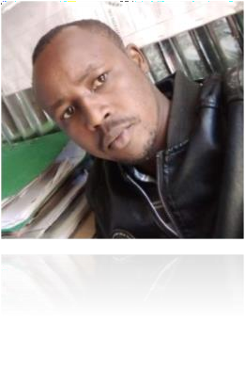
Civil Engineering Professional
As a final-year student, I hold a Master of Professional Engineering (Civil) at the University of Technology Sydney (UTS), with more than three years of experience in the successful design and implementation of infrastructure projects. Over the course of my studies and career, I have come to love the field of civil engineering and specifically, I am interested in the topics of sustainability, structural longevity, and community-focused development. My passion lies to play a role in global development, through improving the infrastructure systems, and providing innovative solutions to real-life challenges, and all based on engineering. My professional experience cuts across a number of key domains of civil engineering, such as geotechnical design, tunneling project, railways, and project management in engineering. I blend technical accuracy and on-site practical management experience, which has allowed me to be able to play a contributing role in the infrastructure projects that are not only of technical requirements but also of sustainable development and long term societal gains. I can combine my analytical thinking and practical implementation, which will make sure that the solutions I offer are technically and practically feasible.
Education
Master of Professional Engineering (Civil).
University of Technology Sydney (UTS), NSW.
Aug 2023 – Present

B.S. in Civil Engineering.
Technical University of Mombasa, Kenya.
2012 – 2018
Professional Experience
Construction Site Management
Site Engineer
Swift Builders and Civil Engineering Ltd, Nairobi, Kenya.
Jan 2019 – Jul 2023
- Overseen and managed the key construction projects successfully and making sure that all the Health, Safety, and Environment (HSE) regulations are adhered to and that all the projects follow the sustainability standards throughout all the project stages.
- Staged logistics processes and partnered with various stakeholders such as contractors, consultants and suppliers to deliver the project efficiently and smoothly.
- Introduced strong quality assurance and control processes which enhanced the efficiency, compliance and the final performance results of the project.
- Determined and suggested workflow optimization methods that led to a decrease in operational expenses, better financial responsibility, and increased liability management procedures.
- Quality standards and assurance regimes constantly observed and implemented to ensure high standards of construction excellence.
- Intensively participated in the project planning, scheduling and management processes, and facilitated the completion of the complex engineering projects.

Civil Engineering Intern
Export Processing Zone Authority, Athi River, Kenya.
March 2018 – June 2018
- Developed detailed Bills of Quantities (BOQs) of numerous types of civil engineering works, which were accurate and conformed to the project specifications.
- Helped in the planning and testing of the stormwater management and drainage systems to improve the resilience of infrastructure and environmental sustainability.
- Monitored on-site labour work, quality workmanship standards and safe working practices.
- Attended stakeholder meetings to review engineering drawings, talk about project progress, and solve technical issues that arose.
- Maintained and updated daily progress reports, Work Health and Safety (WHS) documentation to ensure effective tracking and compliance of the project.

Civil Engineering Intern
Rotunda Contractors, Ltd, Nairobi, Kenya.
May 2016 – Sept 2016
- Helped in planning project processes such as review of site survey, technical drawings and location data to ascertain that the project was feasible and accurate.
- Assisted senior engineers in documentation, technical reporting, and quality assurance procedures.
- Developed comprehensive Bills of Quantities (BOQs) of different civil engineering projects, which was used in cost estimation and budgeting activities.
- Designed and implemented stormwater and drainage systems, improving performance and sustainability in infrastructure.
- Engaged in on-site tasks, quality workmanship and adherence to engineering principles and safety measures.
Core Skills & Expertise
Technical Knowledge
- Skilled in engineering and design software such as AutoCAD, ArchiCAD, PLAXIS and ABAQUS.
- Knowledgeable in project planning and project scheduling software like Microsoft Project.
- High level of expertise in Microsoft Office Suite to document, analyze and report.
- Communication & Teamwork
- Well-coordinated stakeholders and organizational competencies among multidisciplinary teams.
- Demonstrated team work skills in cross-functional teams.
- Exhibited strong team management and coordination skills.
- Humanitarian project coordination and youth organization initiatives experience.
Sustainability & Innovation
- Renewable energy systems and sustainable engineering practices knowledge.
- Practice in creating and delivering STEM workshops and education programs.
- High attention to eco-friendly infrastructure development and sustainability.
- Knowledge of green building and environmental-friendly building techniques.
Project Management
- Experienced in conducting feasibility studies and technical tests.
- Cost estimation, budgeting and project financial planning experience.
- Well-established stakeholder relations and coordination.
- Skilled in reporting of progress, monitoring and risk management strategies.

Civil Engineering Competencies
- Knowledge of writing and examining Bills of Quantities (BOQs).
- Good knowledge of HSE compliance standards and Quality Assurance.
- Practical site supervision and construction management experience.
- Skills to read and analyze technical drawings and engineering reports.
Achievements & Awards
Technical Achievements
- And the prediction techniques of advanced predictive modelling are applied in the Railway Mat Analysis to measure the effects of vibration and create effective mitigation measures.
- Applied advanced engineering software like ABAQUS and PLAXIS in order to analyze the distribution of stress in tunnel lining systems and enhance the behavior of structures.
- Effective management and supervision of construction work crews at Swift Builders, bringing in automated workflow procedures that enhanced work efficiency, minimized costs and project reliability.
- Awards & Recognition
- Best Overall, Regional English Contest - 2014.
- Certificate of Participation, Biology Contest – 2015.
- Certificate of Recognition, Freedom Hunger Walk – 2009
Professional Associations
- Engineers Australia Member, Student.
- Institution of Engineers of Kenya, Member.
- Engineer, Board of Kenya, Engineers.
- Professional Reflection
- Swift Builders and Civil Engineering Ltd - Reflection.
Expectations vs Reality
My expectations before working with Swift Builders were mostly influenced by the academic theory and classroom simulations. I expected to work in a very organized and structured work environment where engineering principles would be implemented in an orderly, predictable and systematic way. I also anticipated that my job would be, first of all, observational, and I would shadow senior engineers and support them with some of the less important duties instead of being given any serious responsibilities.
Actual Experience
As a matter of fact, my experience was much more dynamic and challenging than expected. Since the beginning of my career, I was assigned to tasks that demanded excellent technical skills as well as people skills. I engaged in the organization of construction events, interacted with the process of Health, Safety, and Environment (HSE), and compliance with the principles of sustainability. I was not a mere observer but a stakeholder in the areas of stakeholder coordination, logistics planning, and quality assurance. This exposure helped me to gain firsthand experience of the complexity of civil engineering projects, where technical precision has to be synergized with cost-effectiveness, time management, and successful teamwork between diverse groups. My expectations and how it really turned out were very different and very informative.

Key Lessons Learned
The experience made me understand the paramount significance of communication, flexibility, and responsibility in engineering practice. I also learned a better appreciation that civil engineering goes beyond a calculation and design; it is also about effective coordination of numerous stakeholders towards one objective. The handling of logistics, schedules, and financial strains inculcated a sense of professionalism and accountability. Finally, the experience turned out to be a good way of bridging the gap between the theory and practice, giving a full picture of the real-world engineering issues.
Employer Value Proposition
As evidenced by my work experience, I would make a good mix of technical skills and hands-on project management skills with a focus on sustainability and innovation. I can introduce efficiency and compliance through proven experience in implementing quality control measures to improve efficiency and compliance and workflow improvements that can reduce costs and improve operational efficiency. My skills in using engineering software, including AutoCAD, PLAXIS, and ABAQUS, the skills of organization, stakeholder engagement, and the provision of efficient and environmentally friendly projects are assets that employers can count on.
Career Direction
My career goals and orientation have been greatly influenced by my work experiences especially at Swift Builders. I have become highly interested in job opportunities that combine technical engineering design and project management and sustainability aspects. The infrastructure projects that I have been particularly interested in are those that are aimed at sustainable urban transportation and resilient civil infrastructure. In the future, I would like to take on the opportunities that will give me the chance to integrate technical expertise with leadership to provide meaningful and sustainable engineering solutions.
Site Experience Documentation
The field work that I have been exposed to on the construction site gives a realistic picture of what it is like to work in civil engineering practice. The hands-on aspect of the profession is embodied in the partially finished structures, dynamic working environment, and team-work of construction teams. These experiences also helped to solidify the vision that civil engineering is much more than just a design on paper, it is a real thing to be accomplished by hard labor, teamwork, and on-site problem solving. This kind of exposure has enhanced my skills in applying engineering concepts in the real world.
I would never refuse to participate in important conversations regarding civil engineering innovations, sustainable development of infrastructure, and possible collaborative opportunities in the field.

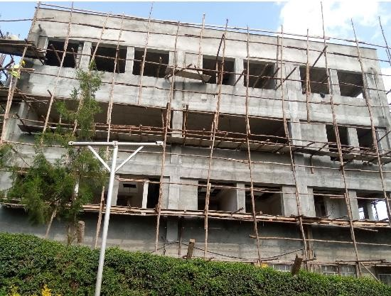
Image 1: Construction Site View
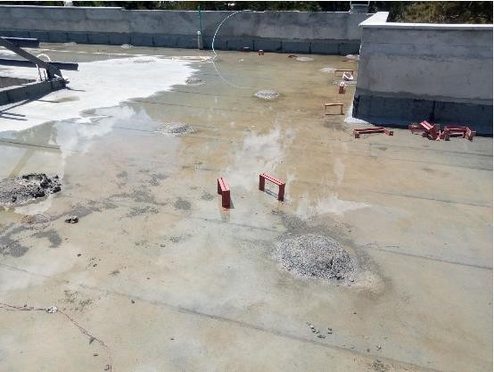
Image 2: Construction Work in Progress
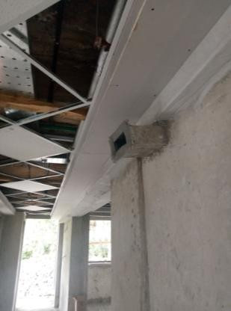
Image 3: Construction Project Development
COVER LETTER

Mathew Kelwon

Civil Engineering Professional

Email: mathewkelwon@yahoo.com

Dear Hiring Manager,
This is to inform you that I have a great interest in a graduate job in the field of Civil Engineering at your company. I am a Master of Professional Engineering (Civil) student in my final year at the University of Technology Sydney and have more than three years of experience in practice in the delivery of infrastructure projects. Both my academic experience and my exposure through site-based experiences have allowed me to achieve a well-rounded engineering profile, one that merges the highest level of technical expertise with the skills of a practical implementation. Specifically, the ideas of sustainability, safety, and community impact drive me the most, and I am determined to make a difference in the development of infrastructure that will enhance the quality of life without harming the environment or ethical principles.
In my career, I have always been able to control my own performance and achieve results at high-pressure and highly responsible work. As a Site Engineer with Swift Builders and Civil Engineering Ltd, I was assigned to a busy construction environment where critical and autonomous decision-making and responsibility were needed. My roles went beyond the routine supervision to organizing site activities, logistics, and ensuring that the Health, Safety, and Environment (HSE) standards were met. As the company was experiencing inefficiencies in its operations, which in turn impacted schedule and cost, I was also the one who initiated quality control and streamlined workflow procedures. These advancements also led to better project performance, minimized risks in operation and more efficient cost management. This experience enhanced what I was capable of working independently, being responsible to my results and always producing high quality results under pressure.
Besides the technical competence, I have been able to acquire good communication skills that allow me to operate well with engineers, contractors, and stakeholders who have different professional backgrounds. In my time at Swift Builders, and my internships, I was often called upon to be an interface between technical departments and site staff. One of my main tasks was to maintain congruence between engineering specifications and construction implementation. I summarized difficult technical drawings and engineering criteria into simple practical guidelines to the non-technical employees and also reported on-site issues to the engineers so that they could be addressed at the right time. This method greatly decreased miscommunications, enhanced coordination and smoother flow of project. Consequently, I have developed a sense of confidence in my skills of presenting a complex engineering concept in a professional, straightforward, and understandable way to as many stakeholders as possible.
My experience has also shown my capability of operating in innovative, proactive and solution-oriented environment. During my time at Swift Builders, I was able to identify some of the inefficiencies in construction processes that were causing excessive delays and adding to the cost. Instead of letting those challenges become a part of the process, I displayed an initiative to study the processes that were being done and offer viable solutions. These were optimization of the task sequencing, team coordination and better logistical planning. These changes led to cost savings and increased reliability of the projects that were implemented. The experience demonstrated my ability to think critically, solve problems, and improve on a continuous basis, and solidified my focus on leading innovation in the engineering practice.
My second strength is that I can successfully manage and use information in complex project situations. During my internships and professional practice, I have had a great deal of experience with the most important engineering documentation, such as Bills of Quantities, technical drawings, and daily progress reports. I was, in one case, tasked with ensuring that proper and current records of site activities were kept so that all the documentation was within the project requirements and compliance requirements. I also acquired a very structured and systematized way of handling information that would be accurate and easily availed to the involved stakeholders. This helped in providing more credible reporting of projects and assisted in making informed decisions throughout the project team. This experience enabled me to appreciate how essential proper management of information is in the successful completion of engineering projects.
Other essential factors are my commitment towards ethical behaviour and professional accountability. In my work at Swift Builders, I always followed the quality assurance protocols and HSE requirements as I appreciated their role in ensuring compliance, safety and professionalism. I also found myself in a number of circumstances where project schedules made it necessary to speed up the work; but I was firm in making sure that everything was done according to the regulations and safety standards. My dedication to transparency and ethical behavior meant that everything was done in a responsible manner and according to the industry standards. This strategy did not only help in ensuring the integrity of the projects I was doing, but also created a sense of trust amongst the stakeholders and members of the team.
Additionally, I have exhibited good teamwork skills and leadership in the course of my engineering experience. Working as a Site Engineer, I had to organize work crews, assign tasks, and check the progress to make sure that project goals were met effectively. I have given direction and assistance to the team members when they required it and this encouraged a team work and a productive atmosphere. I also collaborated closely with the multidisciplinary teams to resolve issues and make sure that everything in the project was aligned. The experiences helped me to acquire leadership skills, improve team performance and make sure that engineering projects are completed successfully.
Besides my work experience, I have been equipped with a good ground in the main aspects of civil engineering such as geotechnical design, tunneling, railway systems, and project management through my academic training. I am also well versed in the application of industry standard programs like AutoCAD, PLAXIS and ABAQUS that I have applied to solve complicated engineering problems and generate feasible solutions. This skill to combine technical knowledge with practical experience enables me to tackle engineering problems with a rigorous analytical approach as well as a practical judgement.
I am very encouraged to embark on my graduate engineer career within an organization that appreciates innovation, sustainability and professional excellence. I believe that my technical skills, work experience, and good work ethics will help me to contribute positively to your team. I am especially attracted to the opportunities that include the creation of sustainable infrastructure and the use of engineering solutions to solve complicated problems of society.
I appreciate you looking into my application. I would be pleased to have a chance to discuss even more how my skills, experience, and professional values can be used by your organization. I am also keen to join your team and further grow up as a professional in the field of civil engineering in an evolving and progressive environment.

Yours sincerely,
Mathew Kelwon

